Install SoX **for windows** and use pysox*

*When python import sox meet error like：

SoX could not be found!

Need to install sox first

1. Download the installer for sox from: <http://sox.sourceforge.net/>

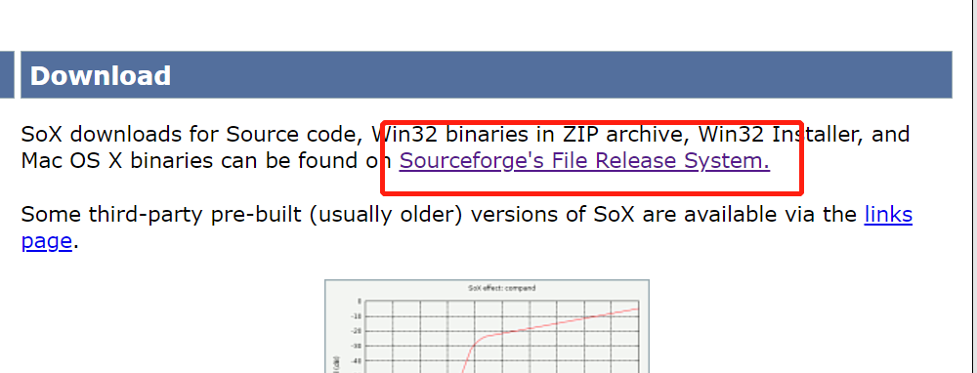

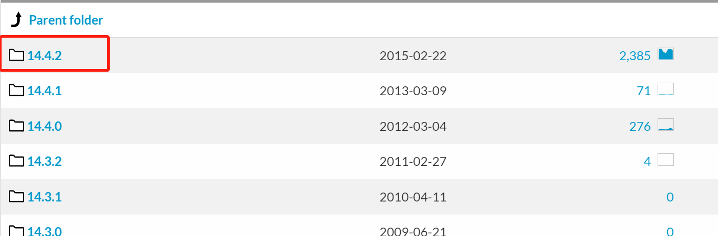

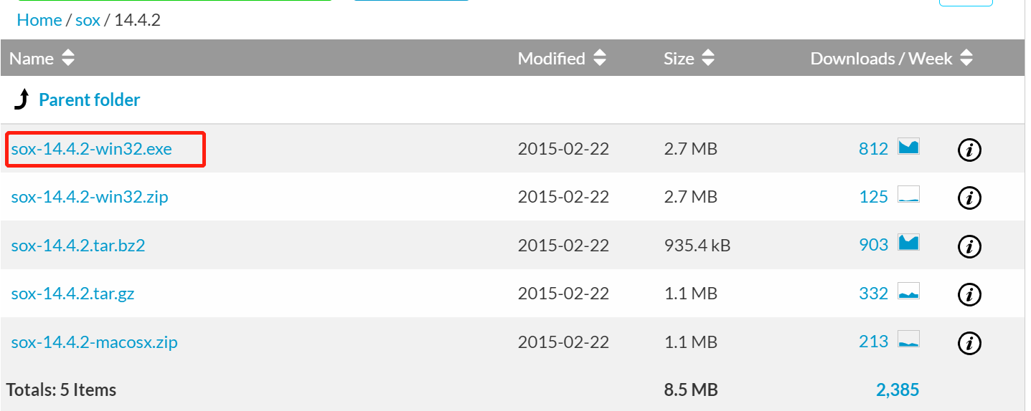

1. After running the exe to install sox, add the sox folder path to the environment variable.

For example:

1648717996(1)

Then, run **sox**

in cmd

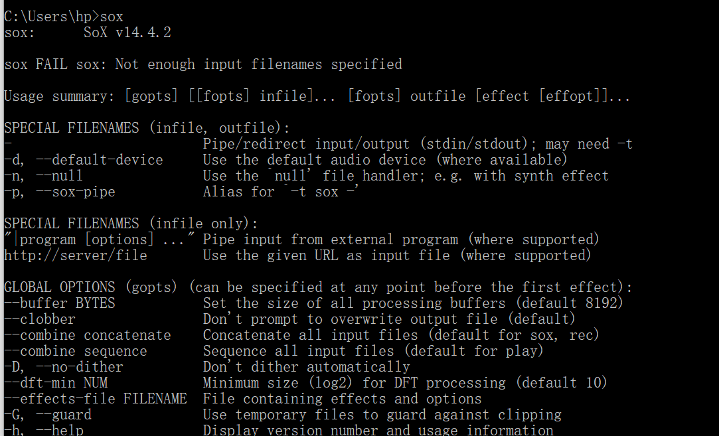

This return means the installation was successful.

1. After successful installation of sox, next, install pysox: **pip install sox**

Finally, input: **python -c “import sox; print(“sox.__version__”)”**

in cmd

Success without error!

For Mac or Linux, more easy to install sox, see:

https://pysox.readthedocs.io/en/latest/#installation